**SMART ANTI-BURGLAR ALARM SYSTEM**

**“SABAS”**

**ABSTRACT**

Security has become an alarming issue in the past half a decade, the cases of identifying and tracking of burglary and theft are difficult. Thus there a necessity of security devices that provide security breach alarm to the owner even if the owner is not present in the building.

The most reliable technology that is being used these days are CCTV that can be only used to identify thieves after the crime has taken place. Thus there is a need of technology that alerts the owner of the building also alerts the surrounding as soon as the thieves enter the building. So that the thieves can be caught red handed without causing much damage to the assets.

Our Device incorporates the latest technology and provides a reliable alarming and alerting device that can be used to protect assets inside the building in the absence of the owner.

The device consumes a lot less power and expenditure compared to a CCTV and relies on highly reliable network i.e. GSM rather Wi-Fi and Internet, thus our device provides larger connectivity area and a reliable connectivity to the main control unit of the device.

**CONTENT**

|  |  |  |
| --- | --- | --- |
| **Slno.** | **Topic** | **Page no.** |
| **i.** | Introduction |  |
| **1** | Requirement specification detail |  |
| **2** | Hardware Requirement |  |
| **3** | Software Requirement |  |
| **4** | Activity Chart |  |
| **5** | Design |  |
| **6** | Coding |  |
| **7** | Test Cases |  |
| **8** | Safety |  |
| **9** | Conclusion |  |
| **10** | References |  |

**DIAGRAMS**

|  |  |  |
| --- | --- | --- |
| **Fig no.** | **Topic** | **Page no.** |
| **Fig. 1** | Arduino Uno |  |
| **Fig. 2** | Relay |  |
| **Fig. 3** | GSM Module |  |
| **Fig. 4** | Power Adapter |  |
| **Fig. 5** | Buzzer |  |
| **Fig. 6** | PIR Sensor |  |
| **Fig. 7** | Connectors |  |
| **Fig. 8** | Arduino IDE |  |
| **Fig. 9** | Outer view of device |  |
| **Fig. 10** | Inner view of device |  |

**Document Conventions**

|  |  |
| --- | --- |
| SABAS | smart anti burglar alarm system |
| PIR | Passive Infrared |
| GSM | Global System for Mobile communication |

**1.Requirement specification detail**

A copy of SRS will be given along with report.

**2. Hardware Requirement:**

**Arduino Uno:**

Arduino is an open-source platform used for building electronics projects, Easy tool for prototyping, consists of both a physical programmable circuit board and piece of software.

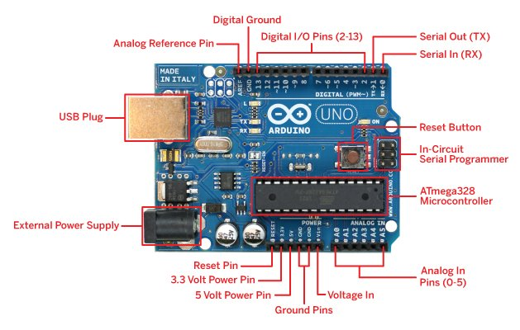

(Fig. 1 Arduino Uno)

|  |  |
| --- | --- |
| Operating System | 5V and 3.3V |
| Input Voltage (recommended) | 7-12V |
| Input Voltage (limits) | 6-20V |
| Digital I/O pins | 14 (6 provide PWM output) |
| Analog input pins | 6 |
| DC Current of 3.3V pin | 50 mA |
| Flash Memory | 32 KB (ATmega328) |
| SRAM | 2 KB (ATmega328) |
| EEPROM | 1 KB (ATmega328) |
| Clock Speed | 16 MHz |
| Microcontroller | ATmega328s |

**Relay:** it provides a AC on/off switch which an Arduino board cannot provide, so it is used turning ON/OFF buzzer if the installed buzzer includes a louder AC buzzer.

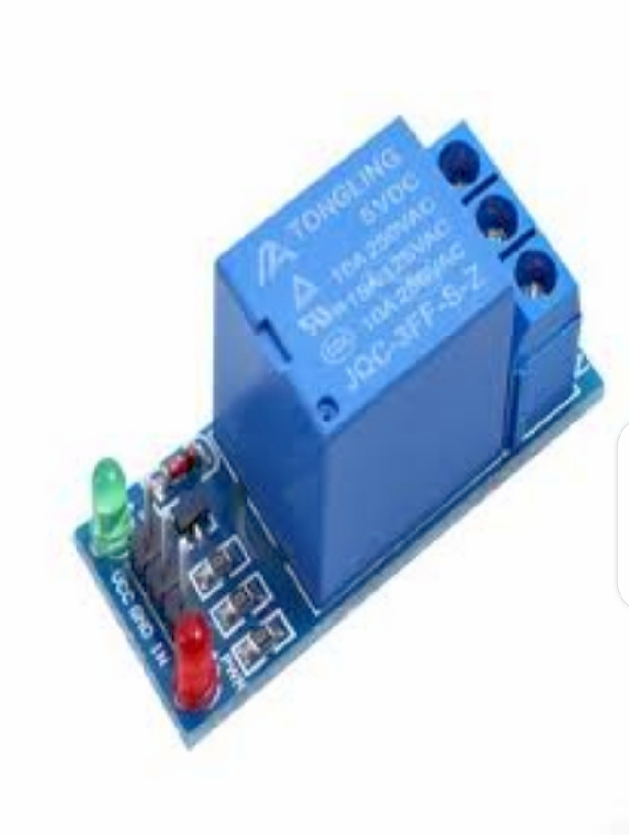

(Fig. 2 Relay)

**GSM (Global System for Mobile Communications) module:**

It is a circuit that will be used to establish communication between a mobile device or a computing machine and a GSM or GPRS System. The modem (modulator-demodulator) is a critical part here. it provides interface to the user

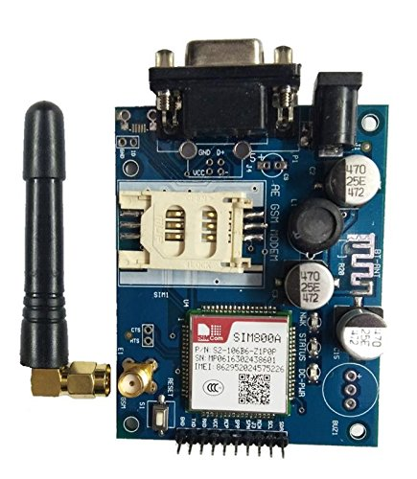

(Fig. 3 GSM Module)

**Power Adapter (12v):** It provides 12v 2a current to the GSM module.



(Fig. 4 Power Adapter)

**5-12v Buzzer:** A piezo electric buzzer used to sound an alarm. It works in 5-12v 0.5amp.



(Fig. 5 5-12v Buzzer)

**Passive Infrared sensor (PIR Sensor):**

PIR sensor is an electronic sensor that measures infrared (IR) light radiating from objects in its field of view. They are most often used in PIR-based motion detectors.

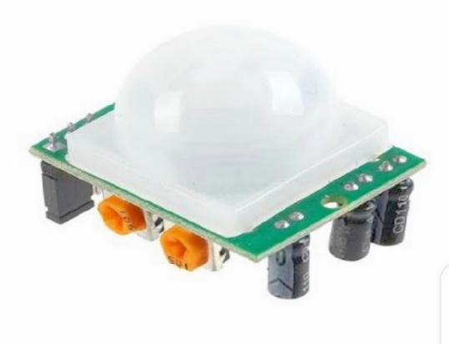

(Fig. 6 PIR Sensor)

|  |  |
| --- | --- |
| **Size** | Rectangular |
| **Output** | Digital pulse high (3V) when triggered |
| **Sensitivity range** | up to 20 feet (6 meters) 110° x 70° detection range |
| **Max range** | 20 feet (6m) |
| **Power supply:** | 5V-12V input voltage for most modules (they have a 3.3V regulator), but 5V is ideal in case the regulator has different specs |
| **No. of Pins** | 3 pins (3-5VCD, Ground, Digital output) |
| **Work** | PIR sensors allow you to sense motion, almost always used to detect whether a human has moved in or out of the sensors range. |

**Connectors:** It joins two pieces of equipment, wire or piping together.

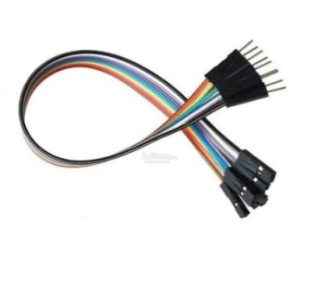

(Fig. 7 Connectors)

**3.Software Requirement:**

* **Arduino IDE:**

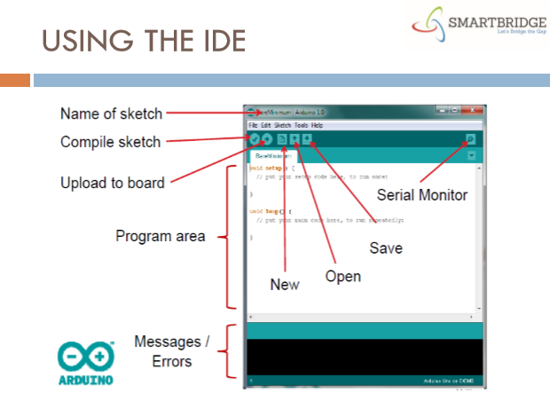

(Fig. 8 Arduino IDE)

Table-2

**4. Design:**

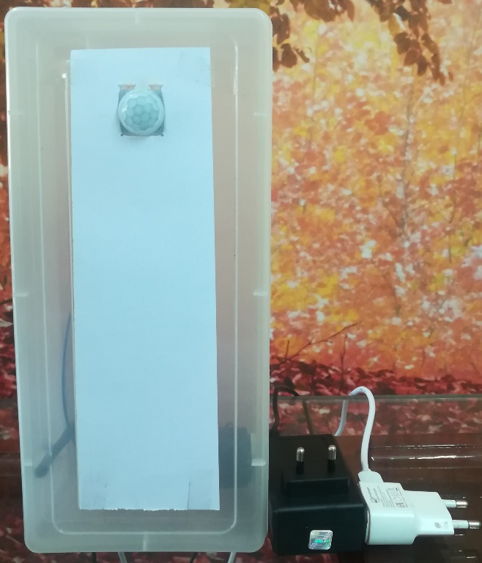**OUTER VIEW**

PIR SENSOR

ARDUINO POWER

CONNECTOR

GSM MODULE POWER CONNECTOR

Fig 9 Outer View of Device

**INTERNAL VIEW**

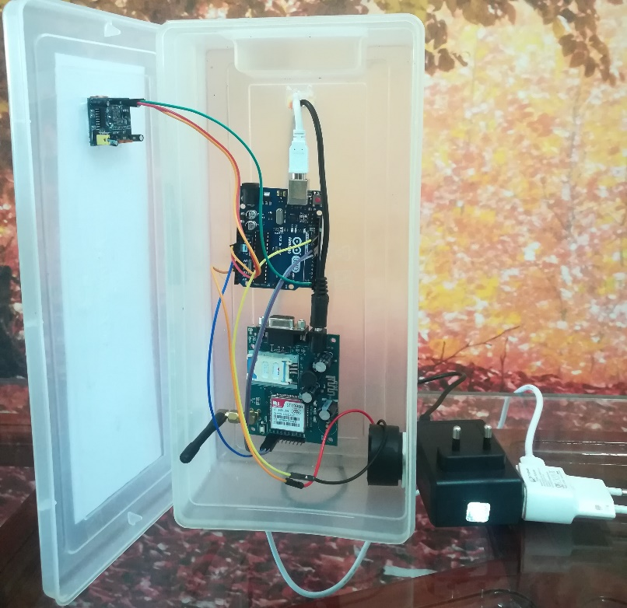

PIR SENSOR

ARDUINO

GSM MODULE

BUZZER

Fig 10 Inner View of Device

**6.Testing of device**-

**Tests Conducted**- the device testing were carried out in several stages where the tests were initially conducted for individual sensors and then the integrated hardware’s were tested and finally the whole device was tested as a whole.

The members of the testing conducted on different stages are as follows-

|  |  |  |  |  |
| --- | --- | --- | --- | --- |
| **Slno.** | **Tests** | **Type of test** | **Members** | **Monitored by** |
| 1. | Module Testing | White box testing | Developers ,Guide Teacher | Guide Teacher |
| 2. | Hardware Integration testing | White Box testing | Developers, Guide Teacher | Guide Teacher |
| 3. | Device Testing-I | White Box Testing | Developers ,Guide Teacher | Guide Teacher |
| 4. | Device Testing –II | Black Box testing | Developers, Client | Developers |
| 3. | Device Security Testing-I | White Box Testing | Developers ,Guide Teacher | Guide Teacher |
| 4. | Device Security Testing –II | Black Box testing | Developers, Client | Developers |

During the deployment of the device the device was tested by the client for its full functionality as mentioned in the SRS.

**HC-SR04**

|  |  |
| --- | --- |
| **Working voltage** | DC 5v |
| **Working current** | 15mA |
| **Working frequency** | 40Mhz |
| **Max range** | 400cm (4M) |
| **Safe working range\*** | 250cm (0.25M) |
| **Min range** | 4cm (0.04M) |
| **Accuracy** | 3mm |
| **Measuring Angle** | 15° |
| **No. of Pins** | 4 (Vcc, Gnd, Trigger, Echo) |
| **Min size of object detected \*** | Varying according to the distance of object from the sensor |
| **Safe Detection area** | 6250cm2 |

**(Ultrasonic Sensor)**

**1.** **\***Safe working range is determined by that distance where the sensor can detect objects without producing garbage values.

**2. \*** The object used to determine the safe working area is of the size 30x30cm.

SAFE DETECTION AREA- 6250CM2

MIN RANGE – 4CM

MAX RANGE -400cm

HC-SR04 SENSOR

SAFE RANGE-250CM

**HC-SR501**

**(Passive Infrared Sensor)**

|  |  |
| --- | --- |
| **Working voltage** | DC 5v |
| **Working current** | 65mA |
| **Output Voltage** | DC 3.3v |
| **Max range** | 10m |
| **Safe working range\*** | 7.5m |
| **Min range** | 4cm (0.04M) |
| **Delay** | 5secs to 5 min |
| **Measuring Angle** | v-30° h-90° |
| **No. of Pins** | 4 (Vcc, Gnd, out) |
| **Min size of object detected \*** | Varying according to the distance of object from the sensor |

1. **\***Safe working range is determined by that distance where the sensor can detect objects without producing garbage values.
2. **\***the objects used for detection were a normal built person.

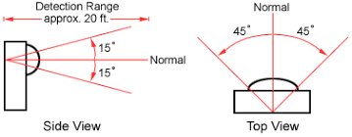

**Test cases-**

**Device Testing-**

|  |  |  |  |  |  |  |  |
| --- | --- | --- | --- | --- | --- | --- | --- |
| Test case id | Objective of the test case | Perquisites | Steps | IP data | Expected result | Actual Result | Status |
| C1 | To validate that the buzzer rings once an intruder is detected | -Device is connected to the power. | -Let the booting sequence of the device to get completed. | -A person should enter the room where the device is installed. | - The buzzer rings continuously. | - The buzzer rings continuously. | pass |
| C2 | To Validate that the message is sent when an intruder is detected | -both the power cords of the device are connected to the power | -Let the booting sequence of the device get completed | - A person should enter the room where the device is installed | -The message is sent to the registered mobile number within 10 secs (may differ depending on network connectivity ) | -The message is sent to the registered mobile number within 10 secs (may differ depending on network connectivity ) | pass |
| C3 | To validate that the person is detected if he enters the room where the device is installed. | - both the power cords of the device are connected to the power | --Let the booting sequence of the device get completed  -Enter the room after boot sequence. | - A person should enter the room where the device is installed | - The buzzer rings continuously.  -The message is sent to the registered mobile number within 10 secs (may differ depending on network connectivity ) | - The buzzer rings continuously.  -The message is sent to the registered mobile number within 10 secs (may differ depending on network connectivity ) | pass |
| C4 | To validate that the device gets reset when the reset message is sent | -both the power cords of the device are connected to the power  -the booting sequence of the device is completed | -Enter the room where the device is installed.  -the buzzer is turned on  -the message to owner is sent | -Send the secret reset message through the phone | -The buzzer stops and the device is ready for detecting a another person again. | -The buzzer stops and the device is ready for detecting a another person again. | pass |
| C5 | To validate that the device turns off when the off message is sent from the phone | -both the power cords of the device are connected to the power  -the booting sequence of the device is completed | -keep the device running and then send the off message to the device | - Send the secret off message to the device. | -the device enters a sleep mode where it won’t detect people. | -the device enters a sleep mode where it won’t detect people. | Pass |
| C6 | To validate that the device turns on after it is put to off state. | -both the power cords of the device are connected to the power  -the booting sequence of the device is completed | - keep the device running and then send the off message to the device | -Send the secret on message to the device via phone. | -the device starts again and is ready for detecting people. | -the device starts again and is ready for detecting people. | Pass |
| C7 | To Validate that alar rings if the sensor is damaged. | - both the power cords of the device are connected to the power  -the booting sequence of the device is completed | -Keep The device running and disconnect the sensor. | -Nil | - The buzzer rings continuously. | - The buzzer rings continuously. | Pass |

Hardware testing / Module Integration testing-

|  |  |  |  |  |  |  |  |
| --- | --- | --- | --- | --- | --- | --- | --- |
| Test case id | Objective of the test case | Perquisites | Steps | IP data | Expected result | Actual Result | Status |
| H1 | To Validate that the GSM models receives a message. | -A working SIM must be present in the GSM module.  -Upload suitable code to the Arduino to send and receive messages.  -Establish serial communication between Arduino and gsm module | -Connect the module to the main switch via adapter.  -Wait for the network led to blink every 3sec. | -Send a message to the SIM inserted in the GSM Module. | -The sent message is received and displayed in serial monitor of Arduino IDE. | -The sent message is received and displayed in serial monitor of Arduino IDE. | Pass |
| H2 | To Validate that the GSM Model sends a message | A working SIM must be present in the GSM module.  -Upload suitable code to the Arduino to send and receive messages.  -Establish serial communication between Arduino and gsm module | -Connect the module to the main switch via adapter.  -Wait for the network led to blink every 3sec. | Send a message to the SIM inserted in the GSM Module. | -The sent message is received and displayed in serial monitor of Arduino IDE. | -The sent message is received and displayed in serial monitor of Arduino IDE. | Pass |
| H3 | To Validate that the PIR Sensor detects people. | -A suitable code in Arduino must be uploaded.  -PIR sensor must connected to the Arduino. | -Open the serial monitor and ask a person to walk towards the sensor from a distance of 25 feet’s.  -Mark the location where the PIR sensor detects the person first.  -Repeat a number of times to obtain a suitable float value | -NIL | -The PIR sensor detects the person at a given range to which the sensitivity of the sensor is set to. | -The PIR sensor detects the person at a given range to which the sensitivity of the sensor is set to. | Pass |
| H4 | To validate that the buzzer can ring for a prolonged period of time. | -Connect the buzzer to vcc and gnd pins of the Arduino | - Connect the Arduino to the power. | -NIL | -The buzzer can ring for a prolonged period of time even if powered from Arduino | -The buzzer can ring for a prolonged period of time even if powered from Arduino | Pass |
| H5 | To Validate that the sensor doesn’t trigger false alarm | -A suitable code in Arduino must be uploaded.  -PIR sensor must connected to the Arduino.  -Buzzer Must be connected to the Arduino. | -Boot up the Arduino.  -Adjust the sensitivity of the sensor till the point where only a person can be detected. | A person walks towards the sensor from a distance of 25 feet’s. | -The Buzzer only rings when detects a human presence objects smaller than human body rare not detected | -The Buzzer only rings when detects a human presence objects smaller than human body rare not detected | Pass |

**7. Safety:**

1. Before usage read the Manual Carefully.
2. Don’t open the device without contacting the developers.
3. Do not operate the equipment with damaged power cord.
4. Do not place appliance near the sunlight.
5. Unplug the appliances before cleaning.
6. If appliance is creating noise unnecessarily, then immediately reset it.
7. Always contact to the developers for setting up the device.
8. Don’t operate in an extremely humid environment.
9. Don’t operate in extreme temperatures.
10. Unplug the device before reallocating the device to reduce the risk of shock injury.
11. Keep away from fire and water.
12. If device is heating too much unplug the device and contact the developers.

**8. Conclusion:**

Through this project, we have developed device that will benefits to our society by reducing the crime related to burglary and providing a cheaper alternative to home security devices. That next batch can carry forward in this field for developing other smart devices for the society.

|  |  |  |  |  |  |
| --- | --- | --- | --- | --- | --- |
| **Sr. No.** | **Phase of the Project** | **Start date** | **End date** | **Actual End Date** | **Status** |
| 1. | Identification of Project | 20/10/19 | 24/10/19 | 24/10/19 | Completed |
| 2. | Requirement gathering | 24/10/19 | 30/10/19 | 30/10/19 | Completed |
| 3. | Requirement analysis | 28/11/19 | 2/12/19 | 2/12/19 | Completed |
| 4. | Hardware study | 4/12/19 | 16/12/19 | 16/12/19 | Completed |
| 5. | Equipment gathering | 2/1/20 | 12/1/20 | 14/1/20 | Completed |
| 6. | Learning Embedded C | 2/1/20 | 22/1/20 | 22/1/20 | Completed |
| 7. | Programming | 22/1/20 | 8/2/20 | 8/2/20 | Completed |
| 8. | Assembly | 8/2/20 | 13/2/20 | 13/2/20 | Completed |
| 9. | Hardware Integration | 13/2/20 | 1/3/20 | 1/3/20 | Completed |
| 10. | Code burn | 1/3/20 | 5/3/20 | 5/3/20 | Completed |
| 11. | Device testing | 5/3/20 | 15/3/20 | 15/3/20 | Completed |
| 12. | Installation | 15/3/20 | 17/3/20 | 17/3/20 | Completed |

**10. Activity Chart:**

**11. References:**

1. Thomas E. Murphy,”Hands-on Research in Complex Systems”,Shanghai Jiao Tong University, June 17 –29, 2012
2. Philips Koopman,“ Embedded Software Testing”, September 30, 2015
3. Adafruit Lady Ada, “PIR Motion Sensor”, 2018-08-22
4. [https://www.amazon.in/ (Product](https://www.amazon.in/(Product) survey)
5. <https://www.flipkart.com/>
6. <https://www.godrejsecure.com/>
7. forum.arduino.cc
8. Local Market (Bazaar )